**WIRED NETWORK USING TCP**

**AIM**

To generate a wired network using TCP in ns2

**ALGORITHM:**

1.START

2.Declare a new Simulator ns and nam nf.

3.Define a procedure finish to execute the namfile.

4.Set the colors for Nodes.

5.Create five Nodes n0,n1,n2,n3,n4 and links with each other.

6.Set the Orientation of the nodes with respect to the nodes with respect to the nodes they are linked with.

7.Set up a TCP Agent and Create Application, FTP

8.Start the Traffic and stop at 1 second and call the finish procedure.

9.Run the Simulator

10.STOP

**SOURCE CODE**

set ns [new Simulator]

set tracefile [open out.nam w]

$ns namtrace-all $tracefile

set n0 [$ns node]

set n1 [$ns node]

set n2 [$ns node]

set n3 [$ns node]

set n4 [$ns node]

$ns duplex-link $n0 $n1 6MB 60ms DropTail

$ns duplex-link $n1 $n2 2MB 50ms DropTail

$ns duplex-link $n2 $n3 10MB 20ms DropTail

$ns duplex-link $n3 $n4 1MB 100ms DropTail

set tcp [new Agent/TCP]

$ns attach-agent $n0 $tcp

set sink [new Agent/TCPSink]

$ns attach-agent $n4 $sink

$ns connect $tcp $sink

set ftp [new Application/FTP]

$ftp attach-agent $tcp

$ftp set type_ FTP

$ftp set packet-size_ 1000

proc finish {} {

global ns tracefile

$ns flush-trace

close $tracefile

exec nam out.nam &

exit 0

}

$ns at 0.1 "$ftp start"

$ns at 5.0 "$ftp stop"

$ns at 5.5 "finish"

$ns run

**OUTPUT**

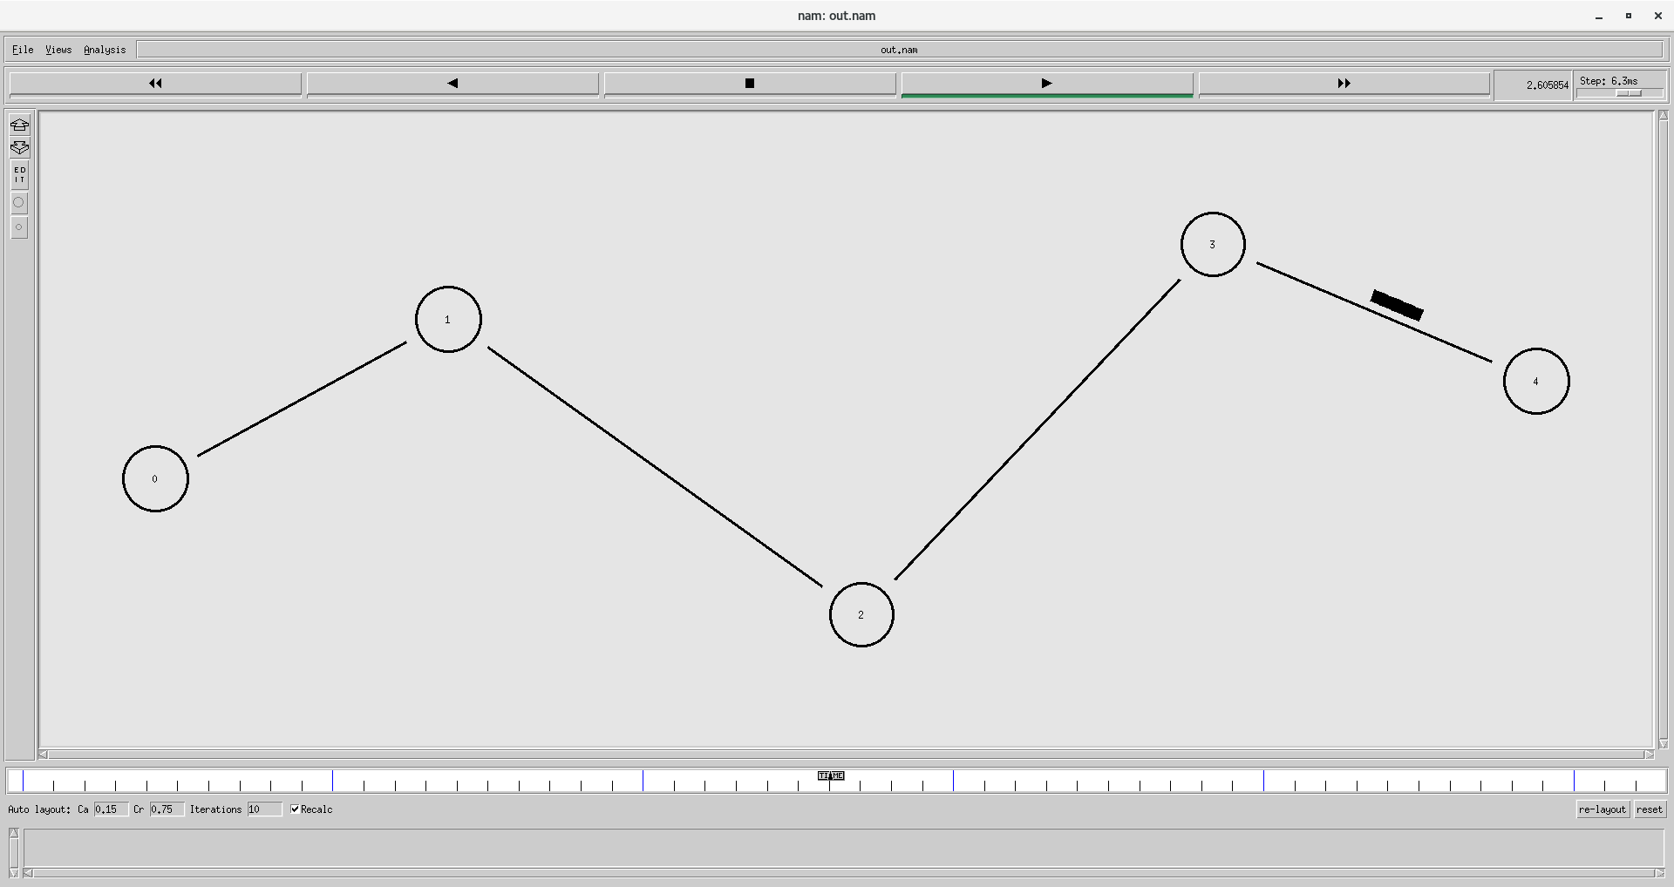

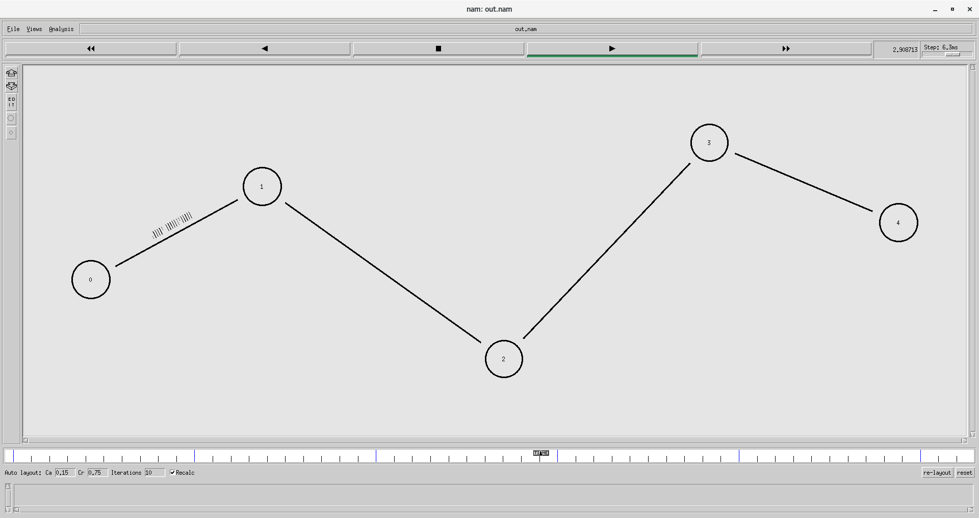

**RESULT**

Hence, wired network using TCP is simulated in ns2.